National Institute of Technology, Warangal



Mess Portal Management System

Group No. 5

Tarun Eswar 22CSB0B19
Sahil Yadav 22CSB0B20
Nikesh Tadela 22CSB0B21
Hema Venkat 22CSB0B22

Department of Computer Science and Engineering

Table of Contents

Abstract...............................................................................................................................................

1 Introduction .................................................................................................................................
1.1 Purpose ................................................................................................................................
1.2 Scope ...................................................................................................................................
1.3 Definitions ...........................................................................................................................
1.4 Overview..............................................................................................................................
1.5 Process Model .....................................................................................................................

2 Software Requirement Specification .............................................................................................
2.1 Overall Description ..............................................................................................................
2.1.1 Product perspective.......................................................................................................
2.1.2 Product functions ..........................................................................................................
2.1.3 User characteristics .......................................................................................................
2.1.4 General Constraints.......................................................................................................
2.1.5 Assumptions and Dependencies ....................................................................................
2.2 Data Flow Diagram…………………………………………………………………………...
2.3 Usecase Document ...............................................................................................................

3 Project Management.....................................................................................................................
3.1 Cost Estimations...................................................................................................................
3.1.1 Functional Point Estimation ..........................................................................................
3.1.2 Efforts ..........................................................................................................................
3.2 Risk Table ............................................................................................................................
3.3 Timeline...............................................................................................................................

4 Design Engineering ......................................................................................................................

4.1 Architectural Design.............................................................................................................
4.2 Data Design .........................................................................................................................
4.3 UML Diagrams……………………………………………………………………………
4.4 Component Level Design ......................................................................................................
4.5 Flowgraph............................................................................................................................

5 Testing.........................................................................................................................................


6 References ....................................................................................................................................


Abstract

The Mess Portal Web Application is designed to streamline the
management of mess facilities within a college environment. The
platform allows students to browse different mess options, view
menus, and book specific time slots for meals, ensuring organized
and efficient meal scheduling that minimizes crowding.

Mess handlers can easily update menus, manage time slots, and
handle additional purchases, enabling real-time adjustments and
better service. The college administration is empowered to oversee
mess operations, including managing mess fee payments, adding or
deleting messes, and controlling user access and authorizations.

By offering a structured approach to meal planning and booking, the
application enhances overall efficiency and improves the dining
experience for students. It will be built with scalability and
performance in mind, ensuring it can accommodate a large user base
while providing high availability, data security, and compliance with
institutional regulations.

Introduction

Purpose

This document outlines the goals and parameters for the development of the Mess Portal Web
Application for NITW. The portal aims to streamline mess operations by improving efficiency
in meal scheduling, menu management, and payment processing for students, mess handlers,
and college administrators. By addressing issues such as overcrowding and enhancing real-
time management capabilities, the application seeks to improve the overall dining experience.

Scope

Students will be able to view available messes, check daily menus, and book specific time slots
for their meals through the portal. Mess handlers can update menus, manage time slots, and
handle additional purchases, while the college administrators will oversee mess fee payments,
add or remove messes, and manage user authorizations. The secure and scalable portal will
ensure reliability, reduce overcrowding during meal times, and maintain user privacy.

Definitions

• MERN: MongoDB, Express.js, React.js, Node.js
• NITW: National Institute of Technology, Warangal
• RESTful API: Representational State Transfer Application Programming Interface
• JWT: JSON Web Token

  - Overview

The rest of the document deals with all the main features of this software. It not only describes various functions but also gives details about how these functions are related to each other. Apart from the data flow diagrams, the document also contains cost estimates for developing this system. Various risks associated with the system have also been mentioned along with the ways to mitigate them.

The timeline chart describing how the entire project was scheduled has been attached followed by the architectural design of the software. At the end a pseudo code for the “handleMessBooking” has been provided. A flow graph has been generated corresponding to this module, cyclomatic complexity has been computed and test cases that were used to test the system have also been mentioned.

Process Model

We choose Waterfall model because of the following reasons:
    - It is relatively simple and easier to understand approach as compared to other models.
    - The requirements are well stated and understood before in hand.

    - In this model we have to complete one stage before proceeding to next. So ,we have clearly defined stages and well understood milestones.
    - The advancement in program does not need to be checked upon by the customer during the process. So this model does not create problem.
    - The requirements are fixed and work can proceed to completion in a linear manner.
    - The Waterfall Model provides a structured approach.

Software Requirement Specification

2.1 Overall Description

    - Product perspective

The aim of the Mess Portal Web App is to streamline and digitize the mess management
process at NIT Warangal for students, mess handlers, and administrators. It's designed as a
standalone web application using modern web technologies, intended to replace time-consuming,
manual processes and bring more efficiency and organization to the mess operations

    - Product functions

- Student Registration & Profile Management: Students can sign up, view mess
menus, book meal time slots, and manage additional purchases like snacks and
beverages, all through their personalized profiles.

- Menu Management & Scheduling: Mess handlers can register, update daily menus,
schedule meal times, and manage extra purchases efficiently.

- Administrative Management: Administrators will have tools to monitor mess
operations, oversee student payments, manage mess facilities, and ensure proper
authorization for mess-related activities.

- Automated Notifications: The system will keep users informed about upcoming meal
times, menu changes, and payment deadlines through automated notifications.

- Data Analytics & Reporting: Provides real-time analytics and reports on student meal
bookings, payments, and mess facility usage statistics.

    - User characteristics

- Students: This includes both undergraduate and graduate students who will use the
Mess Portal to view menus, book meal time slots, and make additional purchases like
snacks or beverages.

- Mess Handlers: Staff members responsible for posting and updating menus,
scheduling meal times, and managing extra purchases for students.

- Administrators: College staff responsible for overseeing mess operations, managing
student payments, and ensuring smooth mess facility management.

- Technical Support: Staff members tasked with maintaining the portal and ensuring its
smooth operation and functionality.

    - General Constraints
- Ensuring the privacy of sensitive information, such as student details and meal bookings, is a
top priority for data security.

- The system must be capable of handling a high volume of users, especially during peak
meal times and events, to ensure scalability.
- The portal should be functional across a variety of devices and screen sizes, including smartphones,
tablets, and desktop computers, ensuring compatibility.
- The system needs to adhere to industry standards and institutional policies to ensure
compliance.

  - Data Flow Diagram

    - DFD Level 0
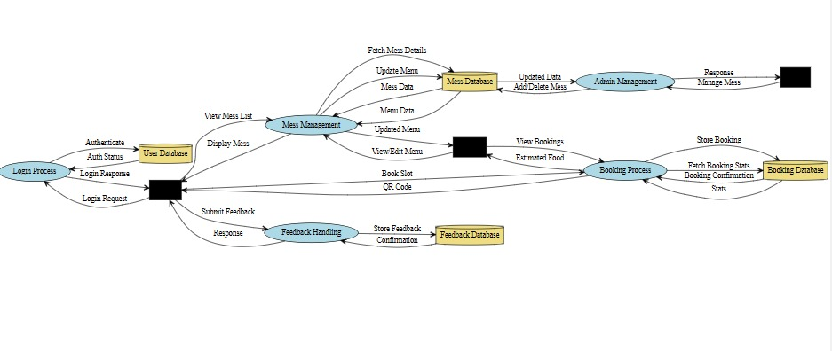

  - USECASE Documents

Use Case ID: | 1.1
Use Case Name: | Menu display
Created By: | Hema Venkat | Last Updated By: Hema Venkat
Date Created: | 15-9-24 | Date Last Updated: 23-9-24
Actors: | Student, Mess Handler, Administrator.
Description: | Students Can view daily or weekly menus, and students use the system to view the available meal options. Administrators ensure that the menu is accurate and up-to-date.
Preconditions: | 1. Student’s account exists and is active.  2. The mess handlers have updated and posted the menus.
Postconditions: | 1. Students successfully view the mess menu.  2. The displayed menu reflects the latest updates by mess handlers.
Normal Flow: | 1.Student logs in.  2.Student navigates to the menu section and views the meals.
Alternative Flows: | Students can filter the menu based on their dietary preferences (e.g., vegetarian, non-vegetarian).
Exceptions:  Includes: | 1.Menu display fails due to a system error.  2.Student cannot view the menu due to network issues.  Manage Student Profile, Update Menu
Priority: | High
Frequency of Use: | Daily
Business Rules: | 1.Only registered mess handlers and administrators can update or post menus.  2.Menus must be updated at least once per week.  3.Students must be logged in to view the menu.  4.Menu items must be clearly categorized (e.g., breakfast, lunch, dinner).
Special  Requirements: | The menu should be updated in real time and must be accessible on mobile devices.
Assumptions: | Menus are posted regularly by mess handlers.

Use Case ID: | 1.2
Use Case Name: | Slot Booking
Created By: | Hema Venkat Last Updated By: Hema Venkat
Date Created: | 16 Sept, 2024 Date Last Updated: 22 Sept, 2024
Actors: | Student, Mess Handler, Administrator
Description: | Students book meal time slots for breakfast, lunch, or dinner using the system. Mess handlers manage the availability of slots, and administrators oversee the process to ensure fair booking.
Preconditions: | The student's account is active and verified.  The mess handler has configured the available time slots for meals.
Postconditions:  Normal Flow: | Students successfully book a time slot for their meals.  Notifications are sent to students confirming their slot booking.  Mess handler logs in and updates the available time slots. Student logs in.  Student navigates to the slot booking section.  Student selects the desired meal time slot.  The system confirms and reserves the slot for the student. A notification is sent confirming the booking.
Alternative Flows: | 1.Administrator manually adjusts the slot availability in case of conflicts or overbooking.  2.Students can cancel or modify their booking before the slot deadline.
Exceptions: | 1.Booking fails due to a system error or network issue.  2.All available slots are booked, preventing the student from selecting a time

Use Case ID: | 1.3
Use Case Name: | View Booking History (Slot and Extras)
Created By: | Hema Venkat Last Updated By: Hema venkat
Date Created: | 18 Sept, 2024 Date Last Updated: 22 Sept, 2024
Actors: | Student  Administrator
Description: | Students view their history of booked meal time slots and any additional purchases, such as snacks or extra items like chicken. Administrators oversee the accuracy of the data and handle any discrepancies in the booking records.
Preconditions: | The student's account is active.  The student has made previous slot bookings or additional purchases.
Postconditions:  Normal Flow: | Students successfully view a detailed history of their meal time slot bookings and any extras purchased.  Data is displayed accurately, including the date, time, and items booked.  Student logs in.  Student navigates to the "Booking History" section.  The system displays a list of previous bookings and purchases. The student can view detailed information about each booking (date, time slot, extras purchased).  The student can filter or export the history if needed.
Alternative Flows: | Administrator intervenes if there is an error in the displayed history. Students can filter the history by date range or type (slots vs. extras).
Exceptions: | Booking history fails to load due to a system error.  No bookings are displayed if the student hasn’t made any previous bookings.
Includes: | Manage Student Profile, Manage Purchase History
Priority: | low
Frequency of Use: | Monthly
Business Rules: | Booking history should be available for at least 6 months.

Students must be able to filter or export their history.
Only purchases and slots booked under the student's account are displayed.
Special Requirements: | The booking history must be updated in real time and accessible on both mobile and desktop devices.
Assumptions:

Use Case ID: | 1.4
Use Case Name: | Student Feedback on Mess
Created By: | Hema Venkat Last Updated By: Hema Venkat
Date Created: | 20 Sept, 2024 Date Last Updated: 20 Sept, 2024
Actors: | Student, Mess Management, Placement Cell
Description: | Students provide feedback about the mess services, allowing the management to address concerns and improve food quality and service.
Preconditions:  Postconditions: | A student account exists.  The mess services are operational.  Feedback is submitted successfully.  Feedback information is available for mess management review. monitor registrations.
Normal Flow: | Student logs in to the system.  Student navigates to the feedback section.

Student submits feedback regarding the mess services.
Mess management reviews feedback for action.
Alternative Flows: | If the student wants to update feedback, they can edit their previous submission before the deadline.  Placement cell intervenes to request specific feedback if necessary.
Exceptions: | Feedback submission fails due to system error.  The student’s session times out before feedback is submitted.
Includes: | Manage Student Profile
Priority: | low
Frequency of Use: | Weekly
Business Rules: | Only registered students can submit feedback on mess services. Feedback must be submitted within the designated feedback period.  Anonymous feedback may be submitted, but identifiable feedback will be prioritized for follow-up.  Feedback is reviewed within a specified timeframe to ensure timely improvements.
Special Requirements: | Feedback status must be updated in real time to reflect acknowledgment by mess management.
Assumptions: | Students are encouraged to provide regular feedback to improve mess services.

Use Case ID: | 2.1
Use Case Name: | Mess Owners Can Add/Update Items in Menu
Created By: | Nikesh Tadela Last Updated By: Nikesh Tadela
Date Created: | 23 Sept, 2024 Date Last Updated: 23 Sept, 2024
Actors: | Mess Owners, System Admin
Description: | Mess owners can use the portal to add new food items to the menu or update existing items. The system will reflect these changes in real-time, and students will be able to view the updated menu.
Preconditions:  Postconditions: | The mess owner's account exists and is active.  The menu management feature is available in the system. New items are successfully added to the menu.  Existing items are updated with the correct details (price, availability, etc.).  The updated menu is visible to students.
Normal Flow: | Mess owner logs into the system.  Mess owner navigates to the "Manage Menu" section.  Mess owner selects "Add New Item" or chooses an existing item to update.  Mess owner enters the necessary details (item name, price, availability). Mess owner confirms the action, and the system saves the changes. The updated menu is reflected for students.
Alternative Flows: | If the mess owner wants to delete an item, they can select the item and confirm the deletion.

Exceptions: | Menu update fails due to a system error.
Priority: | High
Frequency of Use: | Daily
Business Rules: | Only mess owners and system admins can add or update menu items.  All menu items must have valid details such as name, price, and availability status.  Changes to the menu must be reflected in real time for students.
Special Requirements: | The system must ensure that duplicate items cannot be added.  The interface for adding or updating items should be user-friendly and intuitive.
Assumptions: | 1. Mess owners regularly update the menu as per food availability. 2. Mess owners have access to the system and internet to make changes to the menu.

Use Case ID: | 2.2
Use Case Name: | Manage Extra Purchases by Mess Users
Created By: | Nikesh Tadela Last Updated By: Nikesh Tadela
Date Created: | 23 Sept, 2024 Date Last Updated: 23 Sept, 2024
Actors: | Mess Handlers, Mess Users, System Admin
Description: | Mess handlers manage the additional purchases made by students in the

 | mess. This includes adding, updating, and tracking items such as snacks, beverages, or any other extras available for purchase in the mess. The system reflects the availability and price of extra items, and purchases made by students are recorded.
Preconditions: | Mess handler has an active account.  Extra items (snacks, beverages) are available in the system for purchase. Students can view and select extras to purchase.
Postconditions: | Extra purchases are successfully added to the student’s order.  The system reflects the updated status of the extra items (availability, price).  The mess handler can track and manage all purchases made. he selected companies.
Normal Flow: | Mess handler logs into the system.  Mess handler navigates to the "Manage Extra Purchases" section. Mess handler adds new extras (e.g., snacks, beverages) or updates the price/availability of existing extras.  Students select extras while booking their meal or on-site at the mess. The system records the purchase and updates the student's bill accordingly.  Mess handler monitors and manages the inventory and purchases of extras.
Alternative Flows: | If an extra item is out of stock, the mess handler can mark it as unavailable in the system.  Mess handler deletes an item that is no longer offered in the mess.
Exceptions: | Failure to record extra purchases due to system error.
Priority: | High
Frequency of Use: | Daily
Business Rules: | Only mess handlers and system admins can manage extra items. Extra items must have valid details such as name, price, and availability.  Students should be able to view the updated list of extras in real time when making a purchase.
Special Requirements: | The system should validate the availability of extras and update

inventory accordingly.
The interface for managing extra items should be user-friendly for quick updates by mess handlers.
Assumptions: | Extras are purchased regularly by students.  Mess handlers have access to the system and internet to update extra purchases.

Use Case ID: | 2.3
Use Case Name: | View and Analyze Mess Data
Created By: | Nikesh Tadela Last Updated By: Nikesh Tadela
Date Created: | 23 Sept, 2024 Date Last Updated: 23 Sept, 2024
Actors: | Mess Handlers, System Admin
Description: | Mess handlers can view and analyze key metrics, including the number of students who ate, remaining food inventory, and extra purchases made. This helps in managing resources effectively and planning for future meals.
Preconditions:  Postconditions: | Mess handler has an active account.  The system has tracked data on meals, inventory, and purchases. Mess handler successfully views and analyzes the necessary data.  Reports are generated for meal consumption, inventory levels, and extra purchases.
Normal Flow: | Mess handler logs into the system.  Mess handler navigates to the "View and Analyze Data" section.  The system displays data on:

● Number of students who ate meals.
● Remaining food inventory.
● Number of extra purchases.
Mess handler generates reports or visualizations as needed. Mess handler reviews and takes action (e.g., orders more food).
Alternative Flows: | Mess handler filters data by date or type of meal.  Mess handler exports data as a report.
Exceptions: | Data retrieval fails due to system error.
Priority: | Medium
Frequency of Use: | Daily or Weekly
Business Rules: | Only mess handlers and system admins can access this data. Data should be updated in real time for accuracy.  Historical data should be stored for future reference.
Special Requirements: | The system should provide visual reports for easier analysis. Data must be exportable in standard formats (e.g., CSV). The dashboard should allow for real-time tracking.
Assumptions: | Data on meals and purchases is accurately recorded.  Mess handlers regularly review the data for planning.

Use Case ID: | 3.1
Use Case Name: | Manage Mess Facilities (Add/Remove Messes)
Created By: | Sahil Yadav Last Updated By: Sahil Yadav
Date Created: | 23 Sept, 2024 Date Last Updated: 23 Sept, 2024
Actors: | Administrator, Mess Handler
Description: | Administrators can add new mess facilities to the system or remove existing ones. This ensures that the available mess options are up-to-date and accurately reflect current offerings.
Preconditions: | Administrator’s account exists and is active.  Mess facilities to be added or removed are identified.
Postconditions:  Normal Flow: | New mess facilities are successfully added or existing messes are removed.  The updated list of messes is reflected for all users (students and mess handlers).  Administrator logs in.  Administrator navigates to the mess management section. Administrator selects the option to add a new mess or remove an existing one.  Administrator enters or deletes the necessary information and confirms the changes.
Alternative Flows: | Administrator modifies existing mess details (e.g., name, capacity, location).  Mess handlers are notified of changes to available messes.

Exceptions: | The operation fails due to system error.  Administrator lacks permission to add or remove mess facilities.
Includes: | Manage Mess Facilities, Notification System
Priority: | High
Frequency of Use: | As needed (infrequent)
Business Rules: | Only authorized administrators can add or remove mess facilities.  New mess facilities must meet specific requirements (e.g., safety, capacity, hygiene standards).  Changes to mess facilities must be reflected in the system within 24 hours.
Special Requirements: | Updates must be communicated to students and mess handlers in real time via notifications.
Assumptions: | Administrators will maintain accurate records of available messes, and any updates will be based on real-world changes.

Use Case ID: | 3.2
Use Case Name: | Change Catering Service
Created By: | Sahil Yadav Last Updated By: Sahil Yadav
Date Created: | 23 Sept, 2024 Date Last Updated: 23 Sept, 2024

Actors: | Administrator, Mess Handler, Caterer
Description: | Administrators can change the catering service of a mess from one provider (either public or private) to another. This allows flexibility in managing catering services and ensuring the best possible quality for students.
Preconditions: | Administrator’s account exists and is active.  Contracts with both the current and new catering services are valid. The new caterer is registered in the system.
Postconditions:  Normal Flow: | The catering service for the mess is successfully changed.  All relevant parties (mess handlers, students, and the new caterer) are notified of the change.  The new caterer's details are reflected in the system.  Administrator logs in.  Administrator navigates to the mess management section. Administrator selects the option to change the caterer for a specific mess. Administrator enters details of the new caterer and confirms the change. The system updates the caterer's information for that mess. Notifications are sent to mess handlers and students.
Alternative Flows: | Administrator reviews existing caterers before making the change. The current caterer provides feedback or completes outstanding obligations before the switch.
Exceptions: | The caterer change fails due to a system error.  The administrator lacks the necessary permissions to make the change.  The new caterer is not yet registered in the system or fails to meet requirements.
Includes: | Manage Mess Facilities, Update Caterer Details, Notification System
Priority: | Medium
Frequency of Use: | infrequent (as needed when contracts change)
Business Rules: | Only authorized administrators can change the caterer of a mess. The new caterer must meet predefined quality and safety standards. All caterer changes must be reflected in the system within 48 hours of

 | approval.
Special Requirements: | The change must be communicated to students and mess handlers via real-time notifications, and meal schedules should be adjusted if necessary.
Assumptions: | The new caterer will have been fully vetted and approved before the switch, and all necessary documentation will be provided.

Use Case ID: | 3.3
Use Case Name: | Handle Payment Operations
Created By: | Sahil Yadav Last Updated By: Sahil Yadav
Date Created: | 23 Sept, 2024 Date Last Updated: 23 Sept, 2024
Actors: | Administrator, Student, Mess Handler
Description:  Preconditions: | Administrators handle payment operations related to mess services, including fee collection from students, payment confirmations, and refunds. This ensures that all financial transactions related to the mess are properly recorded and managed.  Administrator’s account exists and is active.  Student accounts are registered and active.  The payment gateway or system is functional and integrated with the mess system.
Postconditions: | Payments are successfully processed, and records are updated.

Students receive confirmation of their payment.
Administrators and mess handlers have access to updated payment records.
Normal Flow: | Student logs in and navigates to the payment section.  Student views outstanding payment details (e.g., monthly mess fees, extra purchases).  Student selects the payment option and enters payment details. Payment is processed through the payment gateway.  The system confirms payment and updates the student's account. Administrator reviews payment records and confirms successful transactions.
Alternative Flows: | Students can choose different payment methods (e.g., credit card, bank transfer, digital wallets).  Administrators process refunds if necessary (e.g., student withdraws from the mess for a term).
Exceptions:  Includes: | Payment fails due to a system error or network issue.  Insufficient funds or incorrect payment details.  The payment gateway is temporarily unavailable.  Payment Gateway Integration, User Account Management, Notification System
Priority: | High
Frequency of Use: | Frequent (monthly or per meal basis)
Business Rules: | Payments must be processed only through authorized payment gateways.  Refunds must follow institutional policies and be approved by an administrator.  Students must be notified of successful or failed payment attempts in real-time.  Payments should be processed and reflected in the system within 24 hours.
Special Requirements: | The payment system should be secure, support multiple payment methods, and be accessible via mobile devices. Transaction histories should be available for both students and administrators.

Assumptions: | All students will use the mess system for payments, and administrators will ensure regular reconciliation of payment records.

Use Case ID: | 3.4
Use Case Name: | Allocate Students to Mess and Switch Mess
Created By: | Sahil Yadav Last Updated By: Sahil Yadav
Date Created: | 23 Sept, 2024 Date Last Updated: 23 Sept, 2024
Actors: | Administrator, Student, Mess Handler
Description:  Preconditions: | Administrators are responsible for assigning students to specific messes based on availability, capacity, or student preferences. Additionally, administrators can switch a student from one mess to another when needed (e.g., student requests, mess capacity issues).  Administrator’s account exists and is active.  Students are registered and have active accounts.  The list of available messes and their capacities are up-to-date.
Postconditions: | Students are successfully allocated to a mess.  Students' mess assignments are reflected in the system, and mess handlers are notified.  Students requesting to switch messes are reassigned, and the change is reflected in the system.
Normal Flow: | Administrator logs in and navigates to the student-mess allocation section.  Administrator views the list of students and available messes.

Administrator assigns students to messes based on capacity, preferences, or other criteria.
The system updates student profiles to reflect the new mess assignment. Mess handlers are notified of the updated list of students in their assigned mess.
If a student requests a switch, the administrator reviews the request and assigns them to a new mess.
Alternative Flows: | Students may request to switch messes (e.g., due to dietary preferences, location proximity).  The administrator reallocates students when a mess is at full capacity, distributing them across available messes.
Exceptions: | Assignment fails due to system errors.  The selected mess is at full capacity.  The student does not meet specific requirements for the new mess (e.g., dietary needs that the mess cannot fulfill).
Includes:  Priority: | Manage Student Profiles, Manage Mess Facilities, Notification System High
Frequency of Use: | Frequent (at the beginning of each term, with occasional adjustments)
Business Rules: | Students must be assigned to a mess before the term begins or within a set period of joining.  Switching between messes can only happen under specific conditions (e.g., availability of space, valid requests).  Mess assignments and switches must be updated in the system within 24 hours.  Only authorized administrators can perform mess assignments or student switches.
Special Requirements: | The system must handle a large number of students and provide real-time updates to mess handlers. The switch process should be automated as much as possible to prevent delays.
Assumptions: | The messes have been pre-approved for allocation, and students are assigned based on logical factors such as capacity, preferences, or needs.




Project Management

Cost Estimations
    - Functional Point Estimation

Unadjusted Use Case Weight (UUCW)

Use Case Classification | Number of Transactions | Weight
Simple | 1 to 3 | 5
Average | 4 to 8 | 10
Complex | 9 to 13 | 15

Mess Portal System Use Cases

Use Case Name | Classification | Transactions
View Booking History (Slot and Extras) | Simple | 2
Student Feedback on Mess | Simple | 3
Manage Student Feedback on Mess Services | Simple | 3
Menu Display | Average | 5
Slot Booking | Average | 6
Mess Owners Can Add/Update Items in Menu | Average | 4
Manage Extra Purchases by Mess Users | Average | 7
View and Analyze Mess Data | Average | 5
Manage Mess Facilities (Add/Remove Messes) | Average | 4
Change Catering Service | Complex | 9
Handle Payment Operations | Complex | 10
Allocate Students to Mess and Switch Mess | Complex | 12
UUCW Calculation
UUCW = (3 Simple Use Cases × 5) + (7 Average Use Cases × 10) + (3 Complex Use Cases × 15) = 15 + 70 + 45 = 130

Unadjusted Actor Weight (UAW)

Actor Classification | Type of Actor | Weight
Simple | Student | 1
Average | Mess Handler | 2
Complex | Administrator | 3

UAW Calculation
UAW = (1 Simple Actor × 1) + (1 Average Actor × 2) + (1 Complex Actor × 3) = 1 + 2 + 3 = 6 Technical

Environmental Complexity Factor (ECF)

Factor | Description | Weight Score
E1 | Familiarity with web development stack | 1.5 | 1
E2 | Experience with service booking applications | 0.5 | 0.5
E3 | Experience with JavaScript frameworks | 1.0 | 1
E4 | Capability of lead developer/analyst | 0.5 | 1
E5 | Team’s motivation for user-friendly solutions | 1.0 | 1
E6 | Stability of service categories | 2.0 | 1
E7 | Full-time dedicated development team | -1.0 | 0
E8 | Familiarity with modern web technologies | -1.0 | 0

Complexity Factor (TCF)

TCF Calculation
TCF = 0.6 + (13 / 100) = 0.73

Factor | Description | Weight
T1 | Multi-Service Platform | 2.0
T2 | Performance and response time | 1.0
T3 | User Experience efficiency | 1.0
T4 | Service management complexity | 1.0
T5 | Component reusability | 1.0
T6 | Ease of deployment | 0.5
T7 | Intuitive user interface | 0.5
T8 | Cross-platform compatibility | 2.0
T9 | Maintenance and updates | 1.0
T10 | Handling concurrent users | 1.0
T11 | Security and data protection | 1.0
T12 | Third-party integrations | 1.0
T13 | Minimal user onboarding | 1.0

ECF Calculation

ECF = 1.4 + (-0.03 × 8) = 1.16

Use Case Points (UCP) Calculation

UCP = (UUCW + UAW) × TCF × ECF = (130 + 6) × 0.73 × 1.16 = 98.78 Final UCP Calculation Result

Use Case Points (UCP): 98.78

EFFORTS:
Effort (in Person-Hours)=UCP×Effort Multiplier

Effort=98.78×20=1975.6hours

Effort (in Person-Months)=1601975.6​≈12.35person-months
  - Risk Management

Technical Risks:

- Risk: Poor scalability as the user base increases.
- Mitigation: Design the system with scalable architecture (e.g., load balancing and cloud hosting).
- Risk: Bugs or failures in real-time booking and payment operations.
- Mitigation: Conduct thorough testing (unit, integration, and user acceptance testing).

Operational Risks:

- Risk: Mess handlers or students find the interface difficult to use.
- Mitigation: Ensure a user-friendly and intuitive UI with training materials or tutorials.
- Risk: Data breaches or unauthorized access to sensitive information.
- Mitigation: Use encryption, role-based access control, and regular security audits.
Project Management Risks:

- Risk: Delays in project completion due to unclear requirements or resource unavailability.
- Mitigation: Regular progress tracking, detailed requirement analysis, and resource planning.

Environmental Risks:

- Risk: Changes in institutional policies affecting the mess operations.
- Mitigation: Maintain flexibility in system design to allow easy updates or modifications.

Market Risks:

- Risk: Low adoption rate among students and mess handlers.
- Mitigation: Provide incentives for early adoption and actively collect feedback for improvements.

3.3 Timeline

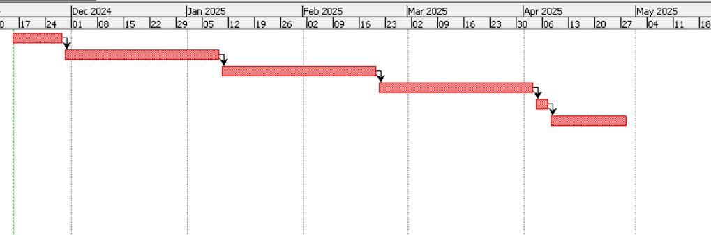

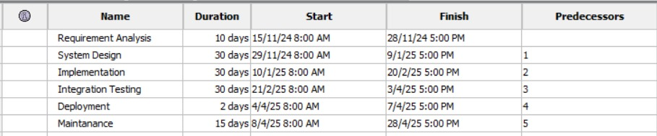

Design Engineering

  - Architectural Design


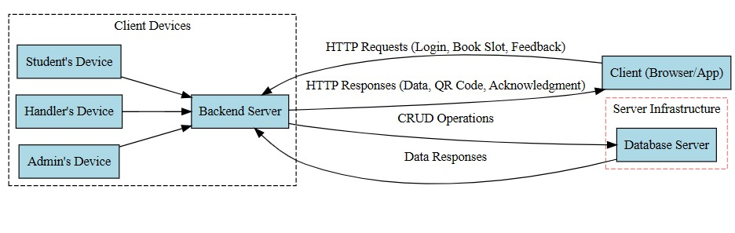

Data Design

- STUDENT DETAILS

Column Name | Data Type | Description
STUDENT_ID | INT | Unique ID for the student
FIRST_NAME | VARCHAR(30) | First name of the student
LAST_NAME | VARCHAR(30) | Last name of the student
EMAIL | VARCHAR(50) | Email address of the student
PHONE_NUMBER | VARCHAR(10) | Student's contact number
ROLL_NUMBER | VARCHAR(15) | Unique roll number
MESS_SELECTED | VARCHAR(50) | Name of the selected mess
ROOM_NUMBER | VARCHAR(10) | Room number in the hostel

- MESS MENU

Column Name | Data Type | Description
MENU_ID | INT | Unique ID for the menu
DAY_OF_WEEK | VARCHAR(10) | Day the menu applies to (e.g., Monday)
BREAKFAST | VARCHAR(100) | Items for breakfast
LUNCH | VARCHAR(100) | Items for lunch
DINNER | VARCHAR(100) | Items for dinner
MESS_NAME | VARCHAR(50) | Associated mess

3. BOOKING DETAILS
Column Name | Data Type | Description
BOOKING_ID | INT | Unique ID for the booking
STUDENT_ID | INT | ID of the student making the booking
MESS_NAME | VARCHAR(50) | Name of the mess
MEAL_TYPE | VARCHAR(20) | Type of meal (Breakfast/Lunch/Dinner)
DATE | DATE | Date of the booking
TIME_SLOT | VARCHAR(20) | Allocated time slot

UML Diagrams :

USE CASE:
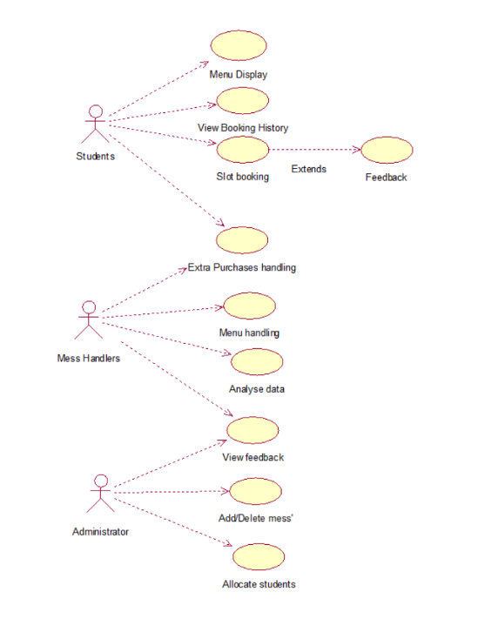

STATE CHART:

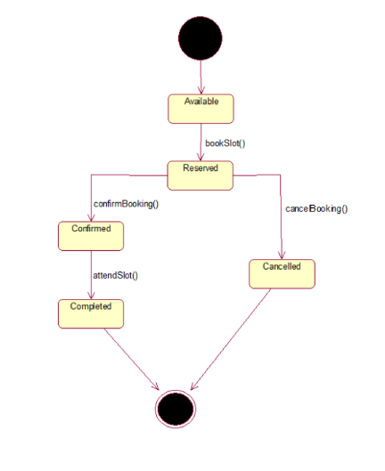
ACTIVITY:

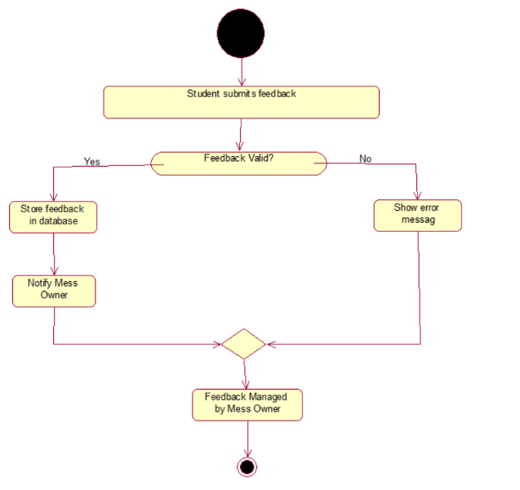

DEPLOYMENT:

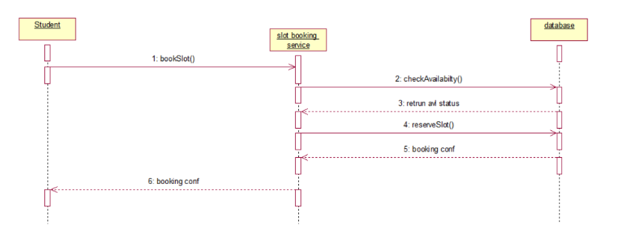
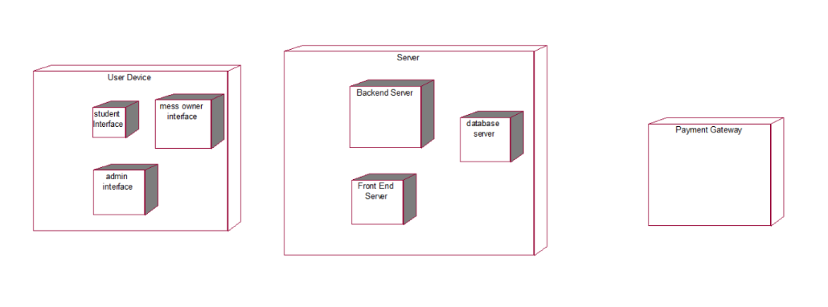

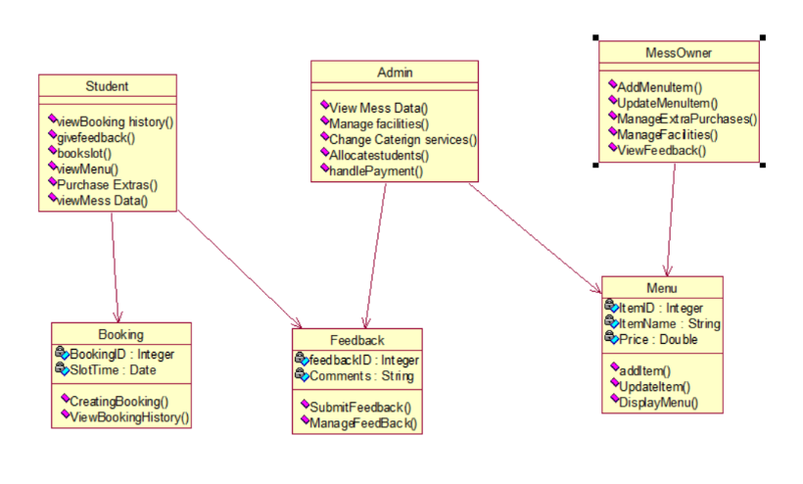
CLASS DIAGRAM:

Component Level Design

PSEUDOCODE

function handleMessBooking(studentId, messId) {

// Mock data for students and messes

const students = [

{ id: 1, name: "John Doe", messBooked: null },

{ id: 2, name: "Jane Smith", messBooked: 1 },

];

const messes = [

{ id: 1, name: "Mess A", capacity: 50, bookings: 20 },

{ id: 2, name: "Mess B", capacity: 40, bookings: 40 },

];

// Get student details

const student = students.find((s) => s.id === studentId);

if (!student) {

return "Student not found!";

}

// Get mess details

const mess = messes.find((m) => m.id === messId);

if (!mess) {

return "Mess not found!";

}

// Check if the mess can take another booking

if (mess.bookings < mess.capacity) {

// Update student and mess details

student.messBooked = messId;

mess.bookings += 1;

return Booking confirmed for ${mess.name}! Remaining slots: ${mess.capacity - mess.bookings};

} else {

return Sorry, ${mess.name} is fully booked. Please choose another mess.;

}

}

FLOW GRAPH

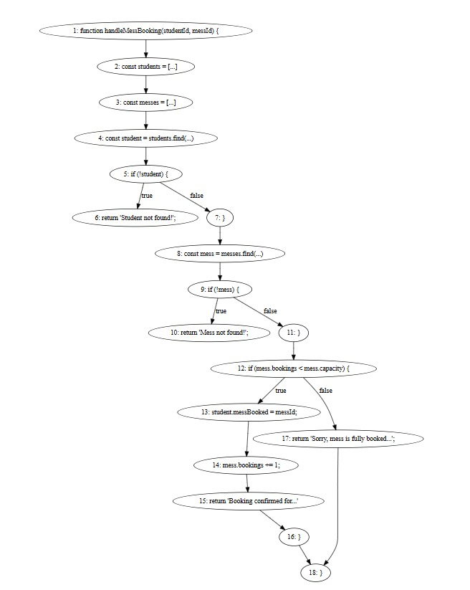

CALCULATING CYCLOMATIC COMPLEXITY

P = 7

E = 18

N = 18
R=1

WHERE P = NO OF PREDICATE NODES

E = NO. OF EDGES
N = NO. OF NODES R = NO. OF REGIONS

CYCLOMATIC COMPLEXITY = E-N+2

= 18-18+2

= 2

5 Testing

TEST CASES

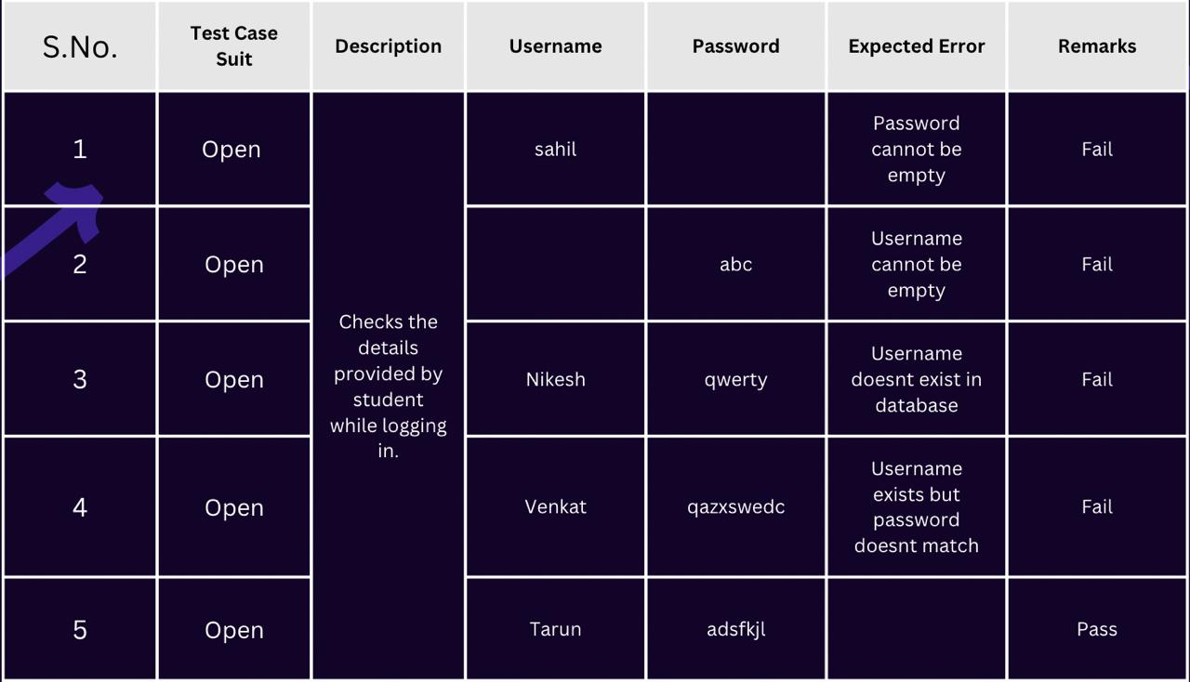

Test case Suits
Open – For new account open requests.
Update -For update account requests

6 References

IIT Madras (https://dost.iitm.ac.in/iitmdost/mess-menus---registration)

IIIT Hyderabad(https://mess.iiit.ac.in/)

Github (https://github.com/dashroshan/mess-management-system)

